input.doc --- Haas --- Introduction To Calculus

Name___________________________________

Refer to the sketches of power functions below to answer questions a - g.

1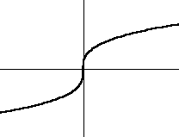 | 2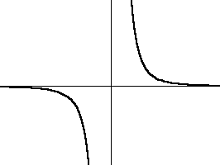 | 3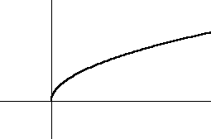
4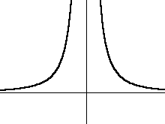 | 5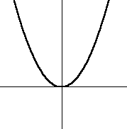 | 6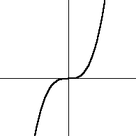

a) Which function(s) are concave down for x>0, and concave up for x<0? _____________

b) Which function(s) are concave up for their entire domain? ______________

c) Which function(s) are increasing for their entire domain? ______________

d) Which function(s) are decreasing for their entire domain? ______________

e) Which function(s) have a domain of all reals? ___________

f) Describe the end behavior of function #1: $x→∞,y→$______ $x→−∞,y→$ ______

g) Describe the end behavior of function #4: $x→∞,y→$______ $x→−∞,y→$ ______

